`

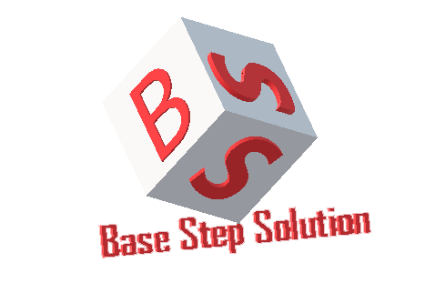

Meeting Minutes

Van Lang Admissions

# Revision Table

|  |  |  |  |
| --- | --- | --- | --- |
| Author | Date | Reason for changes | Version |
| Khoi Nguyen | 30/12/2016 | Initial Document | 1.0 |

Table of Contents

Revision Table 1

I. Purpose 3

II. Participant in meeting 3

III. Content of meeting 3

IV. To do task 4

|  |  |  |  |  |  |
| --- | --- | --- | --- | --- | --- |
| **Writer:** | Khởi Nguyễn | **Location:** | Room 701B | | |
| **Date:** | 30/12/2016 | **Start:** | 15h30 | **Finish:** | 16h30 |

# Purpose

Ask about Physical View & Functional Requirements.

# participant in meeting

Customer : Lecturer Nguyễn Thế Quang

Team Capston:

* Nguyễn Thái Hiền
* Nguyễn Hoàng Anh Tài
* Đoàn Anh Minh
* Trần Xuân Hải
* Nguyễn Anh Khởi
* Nguyễn Xuân Thái Hiền

# Content of meeting

* Drawing model Stand Alone : Consolidate 1 server
* Load Balancer : Load only two or more servers
* Where Redis & Elastic Search?
* Research redis loadbalancer
* Don’t need database backup
* Login on web 🡪 always external : Only 1 network
* 2 types : normal web : Get data via webserver using html , application : flatform 🡪 Get data through webserver via webservice
* What is TCP/IP , Internet?
* All through the API service: json, restful service in nodejs.

# To do task

* Update Physical View
* Continue Architecture

---- *** ----